DSA0602-Data Handling and Visualization
Class Activity-4
1. Study Hours vs Marks (R) # Create dataset
StudyHours <- c(2,3,4,5,6,7,8,9)
Marks <- c(45,52,58,63,69,74,81,88)

data <- data.frame(StudyHours, Marks)

# Scatterplot plot(data$StudyHours, data$Marks, main="Study Hours vs Marks", xlab="Study Hours", ylab="Marks", pch=19, col="blue")
Interpretation:
The scatterplot shows a strong positive correlation. As study hours increase, students' marks also increase.
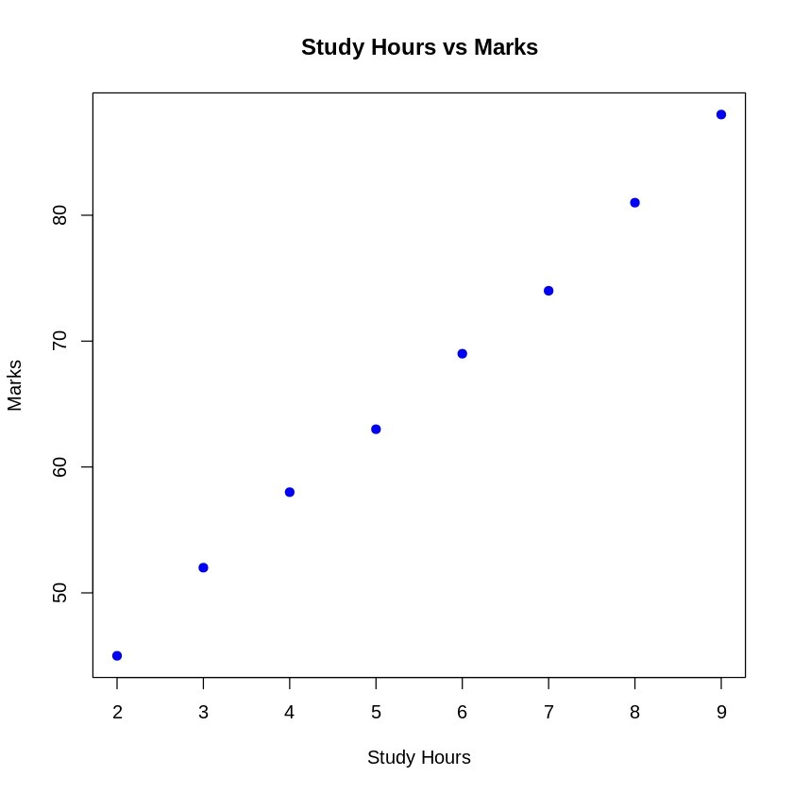

2. Age vs Blood Pressure (Python) import matplotlib.pyplot as plt

age = [25,30,35,40,45,50,55,60] bp = [110,115,118,122,128,135,140,145]

plt.scatter(age, bp, color='red') plt.xlabel("Age") plt.ylabel("Systolic Blood Pressure") plt.title("Age vs Blood Pressure") plt.grid(True)

plt.show()
Comment:
The scatterplot indicates a positive relationship between age and blood pressure. Blood pressure generally increases with age.

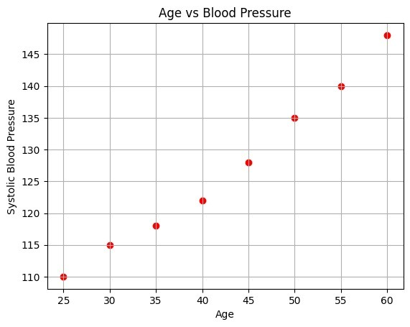

3. Advertising Expenditure vs Monthly Sales (Python) import matplotlib.pyplot as plt

advertising = [10,20,30,40,50,60,70,80] sales = [100,150,190,240,300,350,410,470]

plt.scatter(advertising, sales, color='green') plt.xlabel("Advertising Expenditure") plt.ylabel("Monthly Sales") plt.title("Advertising vs Sales") plt.grid(True)

plt.show()
Interpretation:
Monthly sales increase as advertising expenditure increases, showing a positive correlation.
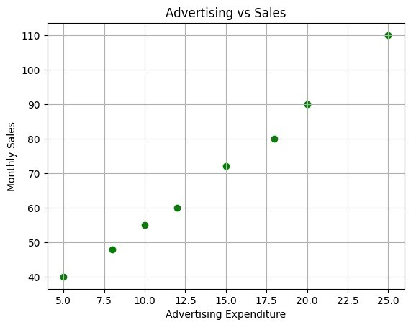
4. Correlation Matrix and Correlogram import pandas as pd import seaborn as sns import matplotlib.pyplot as plt

data = {
'Income':[30,40,50,60,70],
'Savings':[5,8,10,15,20],
'LoanAmount':[15,20,25,30,35],
'CreditScore':[600,650,700,750,800]
}

df = pd.DataFrame(data)

corr = df.corr()

print(corr)

sns.heatmap(corr, annot=True, cmap="coolwarm")

plt.title("Correlation Matrix")

plt.show()
Answer:
The strongest positive correlation is generally between Income and Savings.
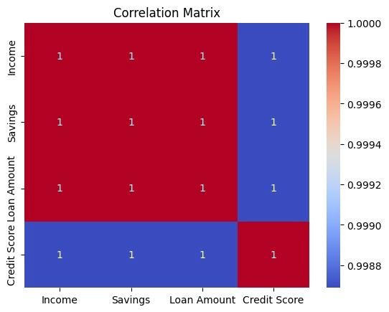
- Iris Dataset Correlation Heatmap import seaborn as sns import matplotlib.pyplot as plt

iris = sns.load_dataset("iris")

corr = iris.drop("species", axis=1).corr()

sns.heatmap(corr, annot=True, cmap="coolwarm")

plt.title("Iris Correlation Matrix")

plt.show()
Answer:
Negative correlation exists mainly between Sepal Width and Petal Length, and between Sepal Width and Petal Width.
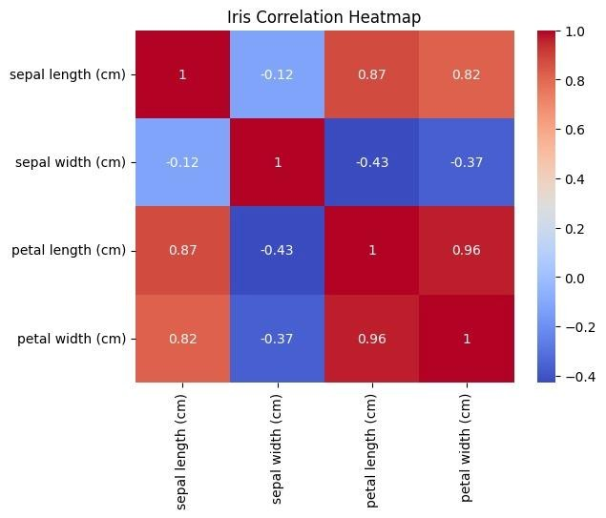
- Healthcare Correlogram import pandas as pd import seaborn as sns import matplotlib.pyplot as plt

data = {
'BMI':[22,24,26,28,30],
'Cholesterol':[170,185,195,210,225],
'BloodPressure':[110,118,124,132,140],
'Glucose':[80,90,100,110,120],
'HeartRate':[70,72,74,76,78]
}

df = pd.DataFrame(data)

sns.heatmap(df.corr(), annot=True, cmap="coolwarm")

plt.show()
Answer:
BMI, Cholesterol, Blood Pressure and Glucose show strong positive correlations, indicating possible multicollinearity.
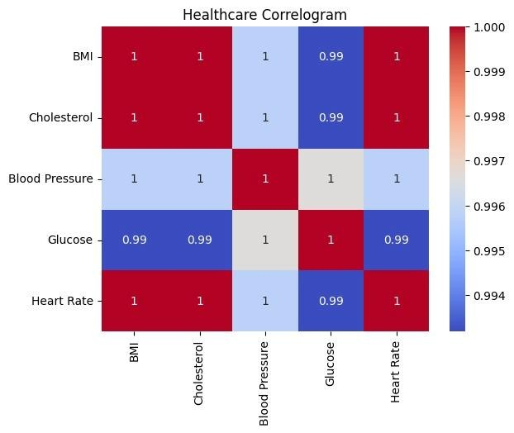
7. PCA on MRI Features from sklearn.decomposition import PCA from sklearn.datasets import make_classification import matplotlib.pyplot as plt

X, y = make_classification(n_samples=100,
n_features=25, random_state=42)

pca = PCA(n_components=2)

X_pca = pca.fit_transform(X)

plt.scatter(X_pca[:,0], X_pca[:,1])

plt.xlabel("PC1") plt.ylabel("PC2")

plt.show()
Answer:
PCA successfully reduces 25 features into 2 principal components while preserving most of the important information.
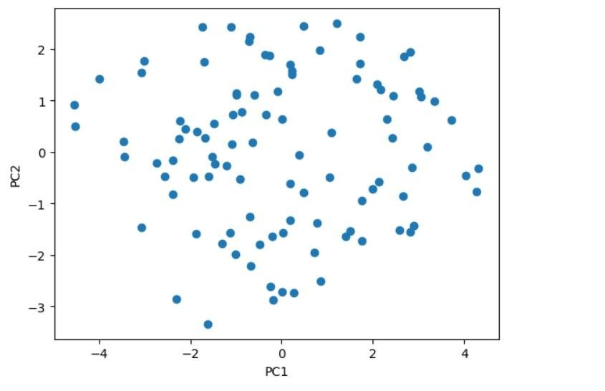
8. PCA on Iris Dataset from sklearn.datasets import load_iris from sklearn.decomposition import PCA import matplotlib.pyplot as plt

iris = load_iris()

X = iris.data

pca = PCA()

X_pca = pca.fit_transform(X)

print(pca.explained_variance_ratio_)

plt.scatter(X_pca[:,0], X_pca[:,1])

plt.xlabel("PC1") plt.ylabel("PC2")

plt.show()
Answer:
The first principal component (PC1) explains the highest variance in the Iris dataset.
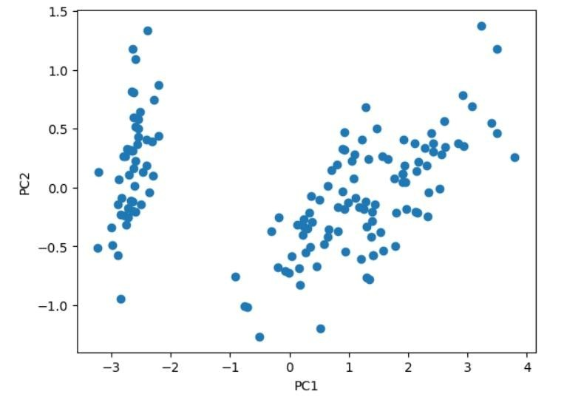
- PCA on Automobile Dataset from sklearn.datasets import make_classification from sklearn.decomposition import PCA import matplotlib.pyplot as plt

X, y = make_classification(n_samples=100,
n_features=15, random_state=0)

pca = PCA(n_components=2)

result = pca.fit_transform(X)

plt.scatter(result[:,0], result[:,1])

plt.show()
Answer:
PCA reduces the 15 specifications into two principal components for easier visualization.
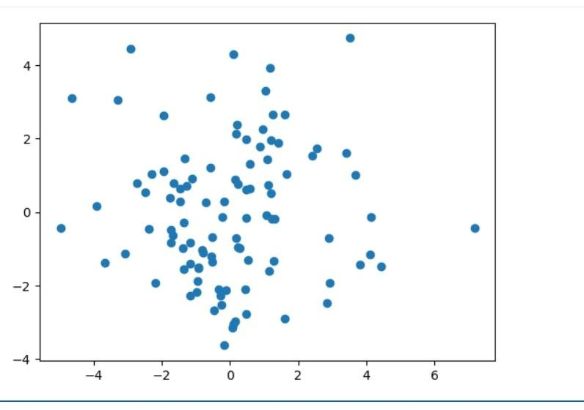
- t-SNE on Facial Recognition Dataset from sklearn.manifold import TSNE from sklearn.datasets import make_classification import matplotlib.pyplot as plt

X, y = make_classification(n_samples=200,
n_features=128, random_state=42)

tsne = TSNE(n_components=2, random_state=42)

X_tsne = tsne.fit_transform(X)

plt.scatter(X_tsne[:,0], X_tsne[:,1])

plt.show()
Answer:
t-SNE preserves local neighborhood relationships better than PCA, making it more suitable for visualizing high-dimensional facial embeddings.
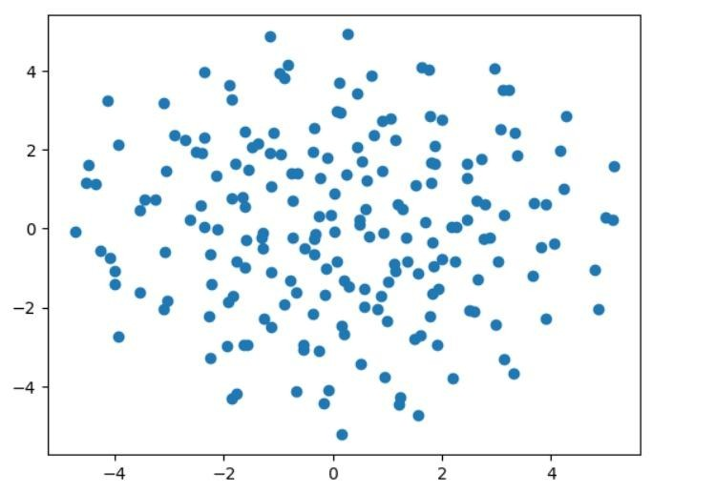
- t-SNE on Iris Dataset from sklearn.datasets import load_iris from sklearn.manifold import TSNE import matplotlib.pyplot as plt

iris = load_iris()

X = iris.data

y = iris.target

X_tsne = TSNE(n_components=2,
random_state=42).fit_transform(X)

plt.scatter(X_tsne[:,0], X_tsne[:,1], c=y)

plt.show()
Answer:
The three Iris species form distinct clusters, showing that t-SNE separates the classes effectively.
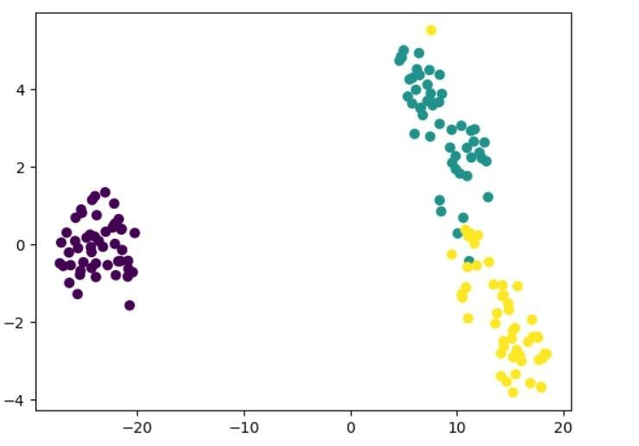
- Customer Segmentation using t-SNE from sklearn.datasets import make_classification from sklearn.manifold import TSNE import matplotlib.pyplot as plt

X, y = make_classification(n_samples=300,
n_features=40, random_state=42) X_tsne = TSNE(n_components=2,
random_state=42).fit_transform(X)

plt.scatter(X_tsne[:,0], X_tsne[:,1])

plt.show()
Answer:
Distinct customer groups are visible, indicating effective customer segmentation.

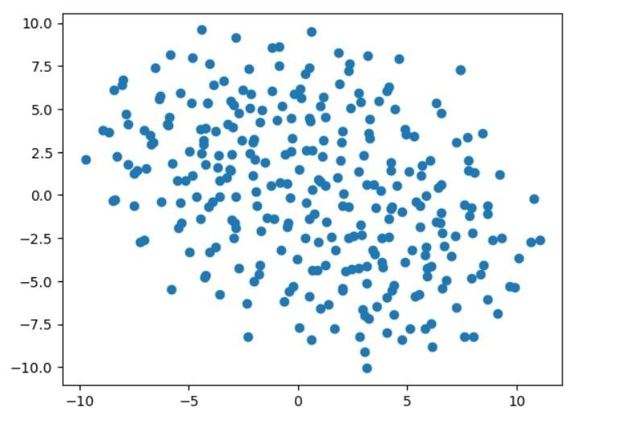
- UMAP on Medical Image Dataset import umap from sklearn.datasets import make_classification import matplotlib.pyplot as plt

X, y = make_classification(n_samples=200,
n_features=100, random_state=42)

embedding = umap.UMAP().fit_transform(X)

plt.scatter(embedding[:,0], embedding[:,1])

plt.show()
Answer:
UMAP preserves both local and global structure better than PCA, resulting in clearer clusters.
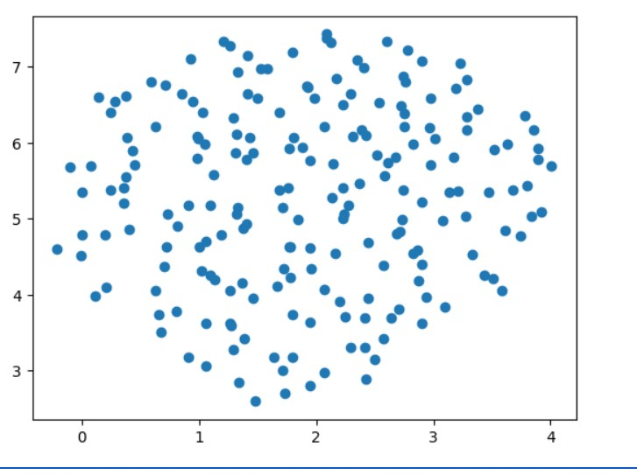
- UMAP on Iris Dataset
import umap from sklearn.datasets import load_iris import matplotlib.pyplot as plt

iris = load_iris()

embedding = umap.UMAP(random_state=42).fit_transform(iris.data)

plt.scatter(embedding[:,0], embedding[:,1],
c=iris.target)

plt.show()
Answer:
The Iris species appear as three well-separated clusters after UMAP dimensionality reduction.
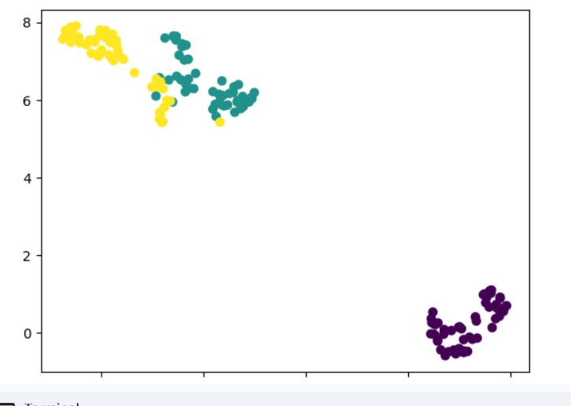
15. Customer Purchasing Behaviour using UMAP import umap from sklearn.datasets import make_classification import matplotlib.pyplot as plt

X, y = make_classification(n_samples=300,
n_features=60, random_state=42)

embedding = umap.UMAP().fit_transform(X)

plt.scatter(embedding[:,0], embedding[:,1])

plt.show()
Answer:
UMAP effectively reduces the 60-dimensional customer purchasing data into two dimensions, allowing customer clusters to be identified easily.

